**CHAPTER 1**

**INTRODUCTION**

**Project Context**

Batangas State University aims to provide a holistic, quality and competent-based education in all level and discipline in accordance to the present trend in globalization and demands of the International community.

The Testing and Admission Office (TAO) provides effective Testing and Admission services designed to support and promote the university’s excellence. The TAO assess the aptitude of incoming student applicants, also they disseminates and evaluates submitted application form and checks the requirements of applicants. They screens out student applicants who are not qualified and releases notice of passing and admission slip to qualified student applicants. Only license testing administrator can administer the examination and interpreting exam results. TAO also have two testing technician also administrative aids. Not all Testing Administrator staff is required to have license at least you are have training for Testing Administrator.

Manual data collection and recording the information of every student is sometimes not helping the staff of TAO to less their time of work. In sum, there are chances that some information of student is not readable, unexpected erasures and incomplete information. Instance the information are needs to be corrected, effort must be doubled in redoing the same forms instead just updating them. The TAO personnel felt uneasy because they are using manual process that sometimes there are possibilities that the applicants have same identities and it took so long to release the result of examination. The result of the examination is confidential so that the applicants and TAO would only be able to view what the result is. During examination day, TAO preventing a scenario like   
 applicants call other people to take an exam for them and applicants who are not qualified/failed to take their chosen course and wants to take an exam again on the other campus at the same university.

This applicant’s portal was initiated by Testing and Admission Office. Applicants who are applying for their chosen course will asked to fill out a template application form which later be submit to TAO and can choose available schedule of examination.

College students in Batangas State University (BSU) Main Campus and other campus of BSU is the one who has majority of applicant’s portal. Every strand has a maximum number of students who are qualified to their chosen course. To be qualified to their strand applicants must reach every maximum numbers of the courses.

The developers believe that the development of Applicants Portal for Batangas State University Testing and Admission Office is essential to enhance its service and would be beneficial to both organizations namely, the applicants and TAO.

**Purpose and Description**

The developers designed an Applicants Portal that deals with helping the staff of Testing and Admission Office and their applicants to update, view and monitor their status. The system provides a public access via website to view the latest announcement and information about the background of TAO and the offer courses. The system provides a web portal for the applicants where they can sign up and they can access the application portal through g-mail accounts that has a link direct to the application portal account to view their information and progress of their status. The portal will provide a template of an application form that can be printed and later should submit to TAO with staple 2x2 picture and also the portal will show exam results including stanine and all information will automatically store to one database.

The system also provides management system for TAO administrator because through the help of this system, the TAO personnel have no longer difficulties in updating each of the applicants. The system also does tagging for the applicants who already take the exam without knowing that the staffs of TAO already check their exams.

The system includes a feature to improve the way of communication between the testing and admission office and applicants. Instead applicants are always going back regularly to TAO through application portal they can check some updates or announcement of the staff of TAO. Having an applicant’s portal eases the staff of TAO to view the updates of applicants also applicants are always questioning TAO time to time of when is the releasing of exam results. All the data given is stored in one database and only TAO know it. Batangas State University is the beneficiaries of the system specially the other campuses, the testing and admission office, the applicants, the administrator and Head of every campus

**Objectives of the Study**

The general objective of the study was to design and develop an applicant’s portal that will monitor applicants/examinees and recording and updating information of applicants more effective and efficient for Batangas State University Testing and Admission Office. The study specially aimed:

1. Assist in monitoring the applicants

2. To develop a system has a reservation of slot for schedule of examination

3. To develop a system that can automatically rank the percentage and give the stanine of the applicant

**Scope and Limitation of the Study**

The developers focused on the development of a system only in screening process of applicants from information dissemination up to admission. The system did not include the application for kinder II, and graduate school, online application of the applicants, administer employee, applicants or teachers. Applicants need to complete all the requirements personally to assess by the staff of TAO. The system includes filling out application form and informing applicants about their examination result/stanine. TAO administrator one staff has a full access to the system and the other staff has limited access to the system they can only encode the information of every applicants, results of examination. Only applicants who have accounts can view their status.

**Definition of Terms**

The following terms which were used in the development of the system are defined herein conceptually and operationally for better understanding of the study.

**Testing and Admission Office (TAO).**  The Testing and Admissions Office is a forefront department tasked with the initial evaluation reception of a student document for enrolment processes. Similar to these purposes is the promotion of the scholarship to assist deserving and qualified students. They provide effective testing and admission services designed to support and promote the university’s vision and mission for academic excellence. The TAO assists students in the discovery, exploration and unveiling of their potentials and make use of such towards holistic, quality and competent based education in all levels and discipline.

Source: Testing and Admission Office (BSU)

**Standard nine (stanine).** (2018)A stanine (“standard nine”) score is a way to scale scores on a **nine-point scale**. It can be used to convert any test score to a single-digit score. Like [z-scores](http://www.statisticshowto.com/probability-and-statistics/z-score/) and [t-scores](http://www.statisticshowto.com/probability-and-statistics/t-distribution/t-score-formula/), stanines are a way to assign a number to a member of a group, relative to all members in that group. However, while z-scores and [t-scores](http://www.statisticshowto.com/probability-and-statistics/t-distribution/t-score-formula/) can be expressed with decimals like 1.2 or 3.25, stanines are always positive whole numbers from 0 to 9.

Source: http://www.statisticshowto.com/stanine/

**Strand** (2016)is purposively designed for those students who are still indecisive of what course or degree they want to pursue in college. A student who finished on this strand can proceed to any college program.

Source: https://usjr.edu.ph/seniorhighschool/track/academic/gas/

**CHAPTER II**

**REVIEW OF RELATED SYSTEMS/STUDIES**

This chapter presents the review of literature and projects closely related to the system conducted by local and foreign developers. This concepts formed the background of the development and provided information that helped developers conceptualize the frameworks necessary to the system’s development.

**Related Systems**

These are the studies that provided concepts and principles used by the developers in conceptualizing and developing the system.

The website developed by University of St. Thomas is almost the same to the present study as it developed a system but it was for campus scheduling. This study was designed to give access to the TAO administration through online. The developed system was the capability to increase the communication between the TAO administrator and applicants. Through the website the admin can post announcements, requirements about the said application portal. They also have calendar for their events while in our system we have scheduling system.

The Online Application System (2017) of Griffith University's International state that it is quick, easy and secure to use. The purpose of this online application is to easily save and edit their application. The system also do receive status updates and to track the progress of your application anytime. It also save and print you application and supporting document.

This study related to the system because it was also develop to lessen the time and effort of the applicants while applying. For them to secure the information of every applicant’s that maybe sometimes it can be loss.

In Graduate Applicant Portal system (2012) of London Global University was adopted to ease communication, track the status and give ability to update directly. This is appropriate, and provides them with immediate and direct access to their application status ad offer letter once it is generated. This improves the service they offer to applicants and should reduce the number of queries receive in TAO administrator. To view the further information of the applicants the staff can view the applicant’s portal. This is much related because the applicants and staff are the one that can view and see the status of every applicants.

A mobile-based Departmental examination Schedule system (2015) for New Era University was developed to give ease to the applicants who are encountered hard time remembering schedule of examination and also no longer to check the list of their schedule of examination. In this system, scheduling is the process of creating a schedule where it consists of a list of time, date and place possible tasks at which, events or actions are intended to take place while in the present system scheduling is use to reserve slot for examination.

A web-based system for University of British Columbia (2013) was developed to help applicants to easily do registration. In their exams, they have exam schedule, exam policies and cancellations, off-campus exams while in this present system before you take the exam you need to reserve a slot on portal and you won’t take exam until you cannot past to TAO.

This study is related to the system because it was developed to avoid vulnerability to errors in book keeping which would consume much time on the enrolment process. This Web-Based Enrolment System with Reservation of Dysas Center for CPA Review is able to help avoid error on record keeping through putting into operation an electronic from upon providing personal data in registration. The system is able to cater more enrolees simultaneously compared to the current process on registration period.

Like Web-Based Enrolment System with reservation of Dysas Center for CPA review work the present developers created a faster making in the enrolment process which allows the TAO Administrator to access faster applicant’s information.

However, faster enrolment process has increased interruption to their work. Hence, face to face communication, mobile devices can’t detect a user’s accessibility. In this study, web-based document was adopted to ease communication and improve the efficiency of work. The improvement in communication, as a result, was projected to improve the time of work.

In Capones, Enriquez, Gutierrez aimed to develop a web-based scholarship management system with sms notification for the office of Representative, 2nd District of Batangas (2017). This system was developed to give ease Congressman Raneo E. Abu, who has scholarship program for the students who need financial assistance for their education. The system is like the most because this could also enhance the service of the office. They create this website which can be accessed by the public to view latest news and events. The system will allow current scholars to log in to their accounts and check the amounts granted to them. It also includes a feature to improve the way of communication. This is much related because the coordinator and the applicants can view their status.

Applicants Portal for Educational Commission for Foreign Medical Graduates (ECFMG) (2017) developed to give applicants quick access to all of the programs, resources, and services offers. This system is related to the present system because it give easiness to the medical graduates. And present system is use easily for the applicants to communicate with the coordinator.

In Joyce Ann Rocamora, aimed to develop an Passport Application via Department of Foreign Affairs (DFA) ePayment portal (2018). This system is develop to help the applicants who are going to pay their passport application and for the renewal of their passport they can easily pay it without living their house or their work. Hassle may occur because you need to manage your time and your work. This system expects that ePayment will help to avoid the nix fixers and scammers. In the present system TAO also avoid other people or outsider to take the responsibility of other applicants.

The National Government Portal (NGP) (2016) is develop to give the citizens faster, more reliable and easier to access to information and services. The Department of Information and Communication Technology – through the Integrated Government Philippines (Gov.Phil) program use internet as an aid of communication. NGP will serve as the backbone of a interoperable and interconnected Government that will improve not only inter agency collaboration but also delivery and service to the citizen. It is related to the present they do the same way to help and enhance their manual process. They can easily do transactions such for a driver’s license, filling of taxes and renewing their passport. They simply need to log in to Single Sign On and they can have access of this portal.

**CHAPTER III**

**DESIGN AND METHODOLOGY**

This chapter presents the strategy and procedures undertaken in the development of the research project.

**Requirement Analysis**

This section includes the status of the current situation which includes the presents system used, the people involved and present facility.

Figure 1 presents the manual process of Testing and Admission Office. It begins with giving of requirements and application by the staff of TAO to the applicant who wants to apply for college student. After knowing the requirements and application form, applicants should complete all the requirements and fill-out application form. Applicant then would submit all the requirements with filled-up form to staff of TAO to assess the applicant whether they are qualified with complete requirement or not. If applicants are qualified they were going pay the testing fee at the cashier’s office and if they are not qualified they need to complete the requirements. After paying the testing fee, Applicants then would go to their respective campus and bring the test permit and pencil on the scheduled date of examination and look for their room assignment for 30 minutes before exam. After the exam the staff of TAO would check the papers of the applicants and applicant where going to present their permit to the staff of TAO on the announced release of examination result. If the applicant passed the exam they were going to get Notice of Passing to the staff of TAO and pay their reservation fee to the Cashier’s Office and if applicants were failed it’s the end of their transaction. After getting Notice of Passing, applicants will go back to TAO and present their receipt to the staff of TAO and wait for issuance of Admission slip. Then applicant will ask for referral slip at the Infirmary, Undergo Chest X-ray in their chosen laboratory. Then they will submit the X-ray result to the Infirmary and submit all the requirements to their respective colleges on the scheduled date of enrollment.

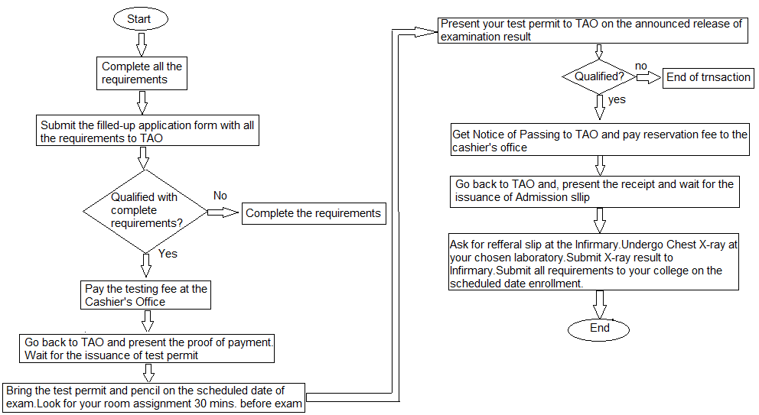

Figure 1.Flowchart Manual Process

The system was designed using a web-based platform and projected to be used to provide are the manual process of the administrator. The users of the system are the applicants, the staff and the administrator. Administrator has access of all records of the system. Applicants can view announcements and requirements through the website of the system. The staff also have access to the system where they can also encode information of applicants.

**Software Requirements Specifications**

This is a description of a software system to be developed. It lays out functional and non-functional requirements, and may include of use cases that describe user interactions that the software must provide.

**Functional Requirements**

The specific functionalities that define what the system is supposed to accomplish are herein listed.

1. **The Testing and Admission Office Administrator**
   1. Can add new users to the system in terms of applicants
   2. Can encode information of the applicants
   3. Can view applicants information
   4. Can add announcement and updates to the portal
   5. Has all the privileges to access all the applicants information
2. **The Staff**
   1. Can encode the applicants information
   2. Can view applicants record
3. **The Applicants**
   1. Can input personal information in the application form of the system
   2. Can view updated announcement
   3. Can view the latest updates
   4. Can choose their want schedule of examination
   5. Can get notice of passing through portal

**Non-Functional Requirements**

This specifies how the system should behave. It is the quality attributes of a system. It works accurately for administrator. If an error occurs, it is expected to recover as soon as possible.

* The system has authentication wherein the administrator and staff has a valid username and password to ensure the security of the system
* The confidential data are protected properly and only the authorized personnel are allowed to access it.
* The developed system should be able to perform well regardless of how many applicants are using the system
* The system will provide a user-friendly interface so that the users can understand and can use the system properly.

**Constraints**

The constraints purpose indicates the limits or restrictions of the system that have been purpose. The purpose system makes to provide solutions on the problem faced by Testing and Admission Office. The system is made from programming languages such as ASP.Net., JavaScript, Bootstrap, HTML and CSS to create the system. The system utilized MySQL for its database, where it was used to store data from the users. For the GUI or Graphical User Interface the developers used HTML, CSS and Visual Basic (VB).

**Design of Software, Systems, Product and/or Processes**

This section describes in detail how the developers designed the system in accordance with the standards.

**Conceptual Design**

Figure 2 shows the Agile Development method that the developers was used as it is client-based system. Developers can make changes during the development process. It also has the contacts of clients in order for them to inform what the development of the system is. Most firms or business uses Agile Methodology because it is an iterative process wherein client is able to comment and suggest on the development per iteration making them satisfied on the final product of the system.

In Requirement Phase, developers interviewed the client in order to find out how the entire testing and admission management process is done and what are the problems that the TAO administrator faced in managing applicants’ information. Next is the Planning and Designing Phase, to be able to develop the system, the developers studied the admission process carefully and determined what are the most suited technologies to be used in order to build the solution. The system was designed based on the plans. Data Flow Diagrams were used to determine the over-all process of the system. Also, the developers used the Use Case Diagram to assign different access types for the user. The developers regularly updated and showed the user progress of the system and have iterations until it met all the necessary requirements. Under the Testing phase, the system was checked and tested in order to determine if it functioned perfectly. The website was uploaded in online to ensure easy troubleshoot in case of internal issues.

Developers used Agile Development because it enables the client to be satisfied with the end product by making improvements and involving clients with development decisions throughout the process. It emphasizes continual communication with the client and ability to adapt to changes and uncertainty. The faster the development, the more it will enable the firm to become first to commercialized a technology and to achieve competitive advantage.

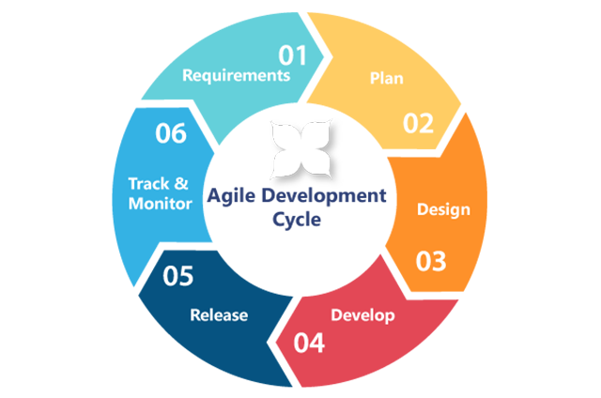

Source:https://www.google.com/search?q=agile+methodology&client=firefox-b-ab&source=lnms&tbm=isch&sa=X&ved=0ahUKEwiTk9LIiZjcAhUKe7wKHTt4BT0Q_AUICigB#imgdii=zcNW0GDyD1z1vM:&imgrc=iRsKgJHGU15AAM:

Figure 2.Agile Development Model

Figure 3 shows the context diagram of the system. It shows the users of the system, also the system can display the requirements, personal information and announcements which the scholars can view. The system allows the applicants to create user account to the administrator. The administrator can input to the system the examination score for the applicant’s. The system can assess user accounts automatically. The system also allows the staff to update applicants status and view and update announcements. The system allows the applicants to input personal information and can generate applicants status based on the records of applicants.

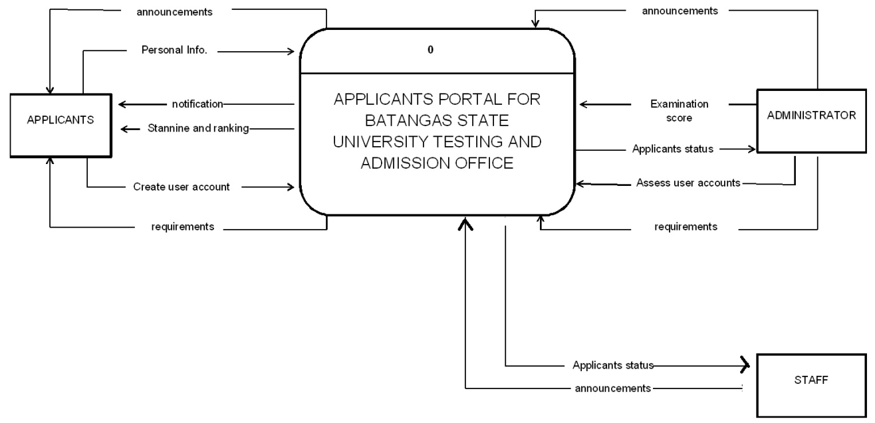

Figure 3.Context Diagram of the System

**Data Model**

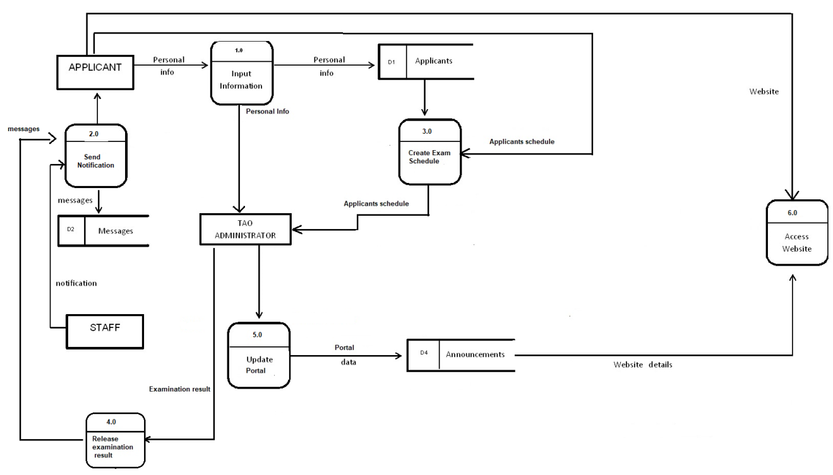Figure 4 show the level 0 data flow diagram of the system. The diagram shows that applicants can input personal information to the website of the system. The system can send notification about the updates of the applicants by the admin while admin can add user’s account, post announcements, and requirements. The scholars can update user information, view requirements, view announcements through the website of the system.

Figure 4.Data Flow Diagram of the system

**Sequence Diagram**

The highlights of the person who play a vital role of the system are presented in this section.

Figure 5 shows the sequence diagram for the applicants. The applicants can register to the website of the system. The website can register the page to the web server and applicants can input information then click submit button. After sending information admin can verify the information and bring back to web server if the information of the applicants information is invalid. Then the web server can send errors of the website system. The website can request to re-enter applicants information and admin accept the new information then save to the database and send confirmation through Gmail account.

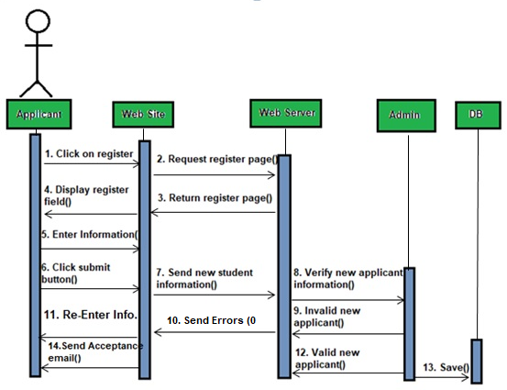

Figure 5.Sequence Diagram of the System

**Software Development Tools**

This section discusses the tools that the developers want to use in the development of the web-based system. For the front end of the system, ASP.Net. JavaScript, Bootstrap, HTML and CSS are the tools they want to use. For the database of the system, they want to use MySQL.

The developers decided to use ASP.Net as a general purpose scripting language that is especially suited for web development HTML is the standard language for creating a web page. The developers decided to use this language because of their familiarity with the language. The external CSS was used so it easier to change and to manage the layout of the website. It provides greater convenience that allows the developers to alter the appearance of the layout to meet the requirements of the client.

The developers also decided to use JavaScript on website development to do things that need to be changed automatically on a formatted data on webpage. This causes a link to appear in a pop-up window, and also cause text or graphic image to change during a mouse roll over.

They also decided to use Bootstrap to make the system responsive. It is easy to get started, has a great grid system, and base styling for most HTML elements. The developers also use MySQL as the network database where account information of all the users will be stored.